**- CREATE INTER VLAN USING IP ROUTING WITH DNS SERVER -**

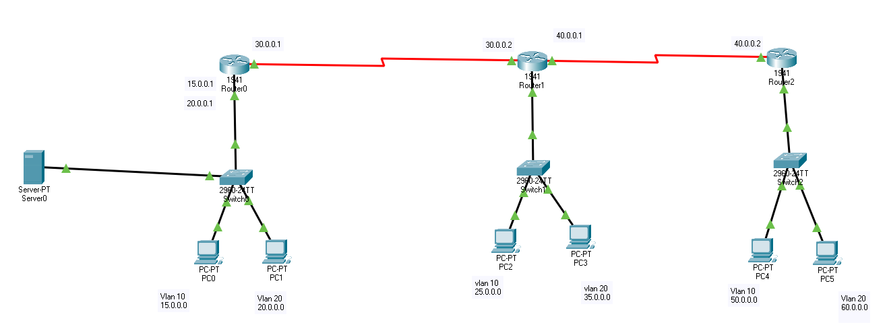

**CREATE VLAN IN ALL 3 SWITCH**

Switch>

Switch>enable

Switch#conf terminal

Enter configuration commands, one per line. End with CNTL/Z.

Switch(config)#vlan 10

Switch(config-vlan)#exit

Switch(config)#vlan 20

Switch(config-vlan)#exit

Switch(config)#

Switch(config)#interface fastEthernet 0/1

Switch(config-if)#switchport mode access

Switch(config-if)#switchport access vlan 10

Switch(config-if)#exit

Switch(config)#

Switch(config)#interface fastEthernet 0/2

Switch(config-if)#switchport mode access

Switch(config-if)#switchport access vlan 20

Switch(config-if)#exit

Switch(config)#

Switch(config)#interface gigabitEthernet 0/1

Switch(config-if)#switchport mode trunk

Switch(config-if)#^Z

Switch#

%SYS-5-CONFIG_I: Configured from console by console

wr

Switch#write

Building configuration...

[OK]

Switch#



**CREATE INTER VLAN IN ALL 3 ROUTER AND CONNECT ROUTER TO ROUTER THROUGH SERIAL PORT**

(ROUTER 0 CONFIGURATION)

Router>enable

Router#conf terminal

Enter configuration commands, one per line. End with CNTL/Z.

Router(config)#

Router(config)#interface g0/0

Router(config-if)#no shutdown

Router(config-if)#exit

Router(config)#

Router(config)#interface g0/0.10

Router(config-subif)#encapsulation dot1Q 10

Router(config-subif)#ip address 15.0.0.1 255.0.0.0

Router(config-subif)#no shutdown

Router(config-subif)#exit

Router(config)#

Router(config)#interface g0/0.20

Router(config-subif)#encapsulation dot1Q 20

Router(config-subif)#ip address 20.0.0.1 255.0.0.0

Router(config-subif)#no shutdown

Router(config-subif)#exit

Router(config)#

Router(config)#interface serial 0/1/0

Router(config-if)#ip address 30.0.0.1 255.0.0.0

Router(config-if)#no shutdown

Router(config-if)#exit

Router(config)#^Z

Router#write

Building configuration... [OK]



(ROUTER 02 CONFIGURATION)

Router>enable

Router#conf terminal

Enter configuration commands, one per line. End with CNTL/Z.

Router(config)#

Router(config)#interface g0/0

Router(config-if)#no shutdown

Router(config-if)#exit

Router(config)#

Router(config)#interface g0/0.10

Router(config-subif)#encapsulation dot1Q 10

Router(config-subif)#ip address 25.0.0.1 255.0.0.0

Router(config-subif)#no shutdown

Router(config-subif)#exit

Router(config)#

Router(config)#interface g0/0.20

Router(config-subif)#encapsulation dot1Q 20

Router(config-subif)#ip address 35.0.0.1 255.0.0.0

Router(config-subif)#no shutdown

Router(config-subif)#exit

Router(config)#

Router(config)#interface serial 0/1/1

Router(config-if)#ip address 40.0.0.1 255.0.0.0

Router(config-if)#clock rate 64000

Router(config-if)#no shutdown

Router(config-if)#exit

Router(config)#

Router(config)#interface serial 0/1/0

Router(config-if)#ip address 30.0.0.2 255.0.0.0

Router(config-if)#no shutdown

Router(config-if)#exit

Router(config)#^Z

Router#write

Building configuration... [OK]



(ROUTER 03 CONFIGURATION)

Router>

Router>enable

Router#conf terminal

Enter configuration commands, one per line. End with CNTL/Z.

Router(config)#

Router(config)#interface g0/0

Router(config-if)#no shutdown

Router(config-if)#exit

Router(config)#

Router(config)#interface g0/0.10

Router(config-subif)#encapsulation dot1Q 10

Router(config-subif)#ip address 50.0.0.1 255.0.0.0

Router(config-subif)#no shutdown

Router(config-subif)#exit

Router(config)#

Router(config)#interface g0/0.20

Router(config-subif)#encapsulation dot1Q 20

Router(config-subif)#ip address 60.0.0.1 255.0.0.0

Router(config-subif)#no shutdown

Router(config-subif)#exit

Router(config)#

Router(config)#interface s0/1/0

Router(config-if)#ip address 40.0.0.2 255.0.0.0

Router(config-if)#no shutdown

Router(config-if)#exit

Router(config)#^Z

Router#

%SYS-5-CONFIG_I: Configured from console by console

Router#write

Building configuration...

[OK]

Router#



(ROUTER 01 ROUTING CONFIGURATION)

Router>

Router>enable

Router#conf terminal

Enter configuration commands, one per line. End with CNTL/Z.

Router(config)#

Router(config)#ip route 25.0.0.0 255.0.0.0 30.0.0.2

Router(config)#ip route 35.0.0.0 255.0.0.0 30.0.0.2

Router(config)#ip route 50.0.0.0 255.0.0.0 30.0.0.2

Router(config)#ip route 60.0.0.0 255.0.0.0 30.0.0.2

Router(config)#ip route 40.0.0.0 255.0.0.0 30.0.0.2

Router(config)#^Z

Router#

%SYS-5-CONFIG_I: Configured from console by console

wr

Router#write

Building configuration...

[OK]

(ROUTER 02 ROUTING CONFIGURATION)

Router>

Router>enable

Router#conf terminal

Enter configuration commands, one per line. End with CNTL/Z.

Router(config)#ip route 15.0.0.0 255.0.0.0 30.0.0.1

Router(config)#ip route 20.0.0.0 255.0.0.0 30.0.0.1

Router(config)#ip route 50.0.0.0 255.0.0.0 40.0.0.2

Router(config)#ip route 60.0.0.0 255.0.0.0 40.0.0.2

Router(config)#^Z

Router#

%SYS-5-CONFIG_I: Configured from console by console

Router#write

Building configuration...

[OK]



(ROUTER 03 ROUTING CONFIGURATION)

Router>

Router>enable

Router#conf terminal

Enter configuration commands, one per line. End with CNTL/Z.

Router(config)#ip route 25.0.0.0 255.0.0.0 40.0.0.1

Router(config)#ip route 35.0.0.0 255.0.0.0 40.0.0.1

Router(config)#ip route 30.0.0.0 255.0.0.0 40.0.0.1

Router(config)#ip route 15.0.0.0 255.0.0.0 40.0.0.1

Router(config)#ip route 20.0.0.0 255.0.0.0 40.0.0.1

Router(config)#^Z

Router#

%SYS-5-CONFIG_I: Configured from console by console

Router#write

Building configuration...

[OK]

Router#